Working stages of the conference  - Submission of APPLICATION FORMS and REPORTS should be not later than March 05, 2021;  - Price for the collection of the articles will be established not later than March 10, 2021;  - Please, provide us with the payment slips confirming the fact of payment for the collection of the articles not later than March 15, 2021;  - You will get the invitation to participate in the conference not later than March 20, 2021;  - Conference Forum – from March 25, 2021  to March 26, 2021.  Conditions of participation in the conference  All the participants are kindly requested to send the following documents to the organizing committee not later than March 05, 2021 by regular mail:  - Application form(s) as annexed here to this information statement;  - Report (in two hard copies) signed by the author(s);  - Сontract for the transfer of the exclusive right (a hard copy must be signed by the author)  - E-REPORT(S) and E-APPLICATION FORM(S) (Please, email on fm-mgpu@tut.by)  See the sample:  JOHNSMITH_APPLICATIONFORM .doc;  JOHNSMITH.doc  It is allowed to apply not more than 2 reports from 1 author.  The collection of the articles will be published at the end of the conference. | XIII International Virtual Research-to-Practice Conference  «Innovative Teaching Techniques in Physics and Mathematics, Vocational and Mechanical Training»  APPLICATION FORM  Family name, Given name, Patronymic (if any)  Science degree,  Academic title (if any)  University/ Organization  Occupation  Title of the report  Indicate the direction of the conference you participate in  Postal address  Contact number with international code  See the example: + 375 29 222 33 44  E-mail  If there are co-authors you worked with and they also have a wish to participate in this conference, please, copy and paste the nested tables and fill them in.  Please, send a hard copy of your report and the APPLICATION FORM to the following postal address:  Physics and Engineering Department,  MSPU named after I.P.Shamyakin  (Please, make a mark on the envelope: for Tatsiana Zdanevich),  28 Studencheskaya Str  247760 Mozyr Belarus  Republic of Belarus  Contact number +375 236 325437  E-mail: fm-mgpu@tut.by  Coordinator of the conference:  Tatsiana Karpinskaya, PhD in Pedagogics, Associate Professor  Contact number +375 29 2150834  Executive secretary of the conference:  Tatsiana Zdanevich  Contact number +375 33 650 35 78 |  | ministry of education  of the republic of belarus  EDUCATIONAL ESTABLISHMENT  «MOZYR STATE PEDAGOGICAL UNIVERSITY NAMED AFTER I.P.SHAMYAKIN»  PHYSICS AND ENGINEERING DEPARTMENT  information statement  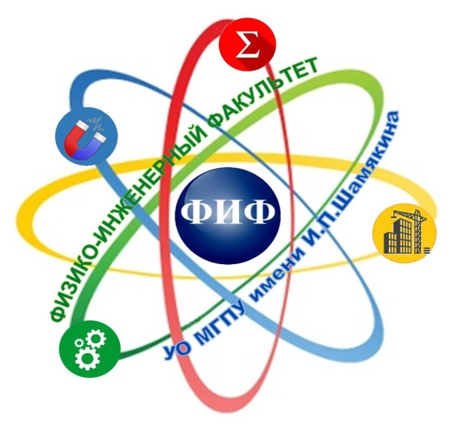  XIII International Virtual  Research-to-Practice  Conference  «Innovative Teaching Techniques  in Physics and Mathematics,  Vocational and Mechanical Training»  March 25–26, 2021
Dear colleagues,  The organizing committee of the conference invites you to participate in the XIII International Virtual Research-to-Practice Conference «Innovative Teaching Techniques in Physics and Mathematics, Vocational and Mechanical Training». The conference will be held on March 25-26, 2021 at the premises of Mozyr State Pedagogical University named after I.P.Shamyakin.  CONFERENCE ORGANIZING COMMITTEE  Chairman of the organizing committee:  V.N. Naunyka, Rector of MSPU named after I.P.Shamyakin, PhD in Physics and Mathematics, Associate Professor  Deputy chairmen:  T.V. Paliyeva, First Vice-Rector for Research, MSPU named after I.P.Shamyakin, PhD in Pedagogics, Associate Professor  I.N. Kovalchuck, Dean of Physics and Engineering Department, PhD in Pedagogics, Associate Professor  Members of the organizing committee:  V. Balan, Professor, Politehnica University of Bucharest (Bucharest, Romania)  N.V. Brovka, Doctor of Pedagogical Sciences, Professor, BSU (Minsk, Belarus);  S.A. Ivashchenko, Doctor of Technical Sciences, BSNU (Minsk, Belarus);  V.N. Orlov, Doctor of Physical and Mathematical Sciences, Associate Professor, Moscow State University of Civil Engineering (Moscow, Russia);  B.V. Palchevsky, Doctor of Pedagogical Sciences, Professor, Minsk City Institute of the Development of Education (Minsk, Belarus);  V.M. Redskov, Doctor of Physical and Mathematical Sciences, B.I.Stepanov Institute of Physics of the National Academy of Sciences of Belarus (Minsk, Belarus);  V.S. Savenko, Doctor of Technical Sciences, Professor, MSPU named after I.P.Shamykin (Mozyr, Belarus);  A.N. Serdyukov, corresponding member, F.Skorina GSU (Gomel, Belarus);  A.V. Chichurin, Doctor of Physical and Mathematical Sciences, Professor, Catholic University of Lublin (Lublin, Poland);  V.M. Shapovalov, Doctor of Technical Sciences, Professor, V.A.Bely Institute of mechanics of metal-polymer systems  (Gomel, Belarus). |  | Directions of the conference:  - Experience and prospects of innovative  teaching techniques in Physics and Mathematics  at the University.  - Innovative teaching techniques in Mathematics, Physics and Informatics at secondary school.  - Modern approaches to Innovative teaching techniques in General Technical Disciplines and Specialized Disciplines at Colleges and Universities.  - Current problems of research in Physics, Mathematics and Informatics.  - Mathematical and Computer modeling of physical systems, processes and phenomena.  - Progressive materials and technologies in machine engineering and building: experience and perspectives.  Working languages of the conference: Belarusian, Russian, English.  SUBMISSION REQUIREMENTS  Report volume: up to 3 pages (А4 format).  - Text editor: MS Word;  - Font: Times New Roman, 14 pt;  - All margins: 25 mm;  - Indention: 1,25 cm;  - Line spacing: single;  - First line: Name and patronymic of the author(s) in initial letters, semi-bold;  - Name of the educational establishment: acronym; city, country are given in brackets;  - Miss the line;  - Name of the report (no shifts, semi-bold,  in capital letters);  - Each of the mentioned above lines is started from paragraph indention, left alignment, no full point at the end;  - Miss the line;  - Starting from paragraph indention – text of the report; full justification. |  | Then miss the line again and indicate “LIST OF REFERENCE LINKS” (indention, alignment to the left edge). Write down the list of references in a line. Indicate each reference by a new line and according to ГОСТ 7.1-2003. References are given in square brackets.  Black-and-white execution is allowed for tables and drawings (font is not less than 12 pt). Illustrations – inside the object Drawing MS Word.  Formulae and symbols are written with the help of formulae built-in editor in MS Equation 3.0, Math Type.  The report in the original must be properly done. There will be no further editing.  The organizing committee reserves the right to select the materials in the conference program and publish lateron.  The materials which do not meet the requirements and sent after the specified terms are not accepted and are not sent back.  Report registration Sample  JOHN SMITH  MSPU named after I.P. Shamyakin (Mozyr, Belarus)  TITLE OF THE REPORT  Text of the Report – – – – – – – – – – – – – – – – – – – – – – – – – – – – – – –– – – – – – – –– – – – –  LIST OF REFERENCE LINKS  - – – – – – – – – – – – – – –.  - – – – – – – – – – – – – – –.  - – – – – – – – – – – – – – –.  - – – – – – – – – – – – – – –.

